# **CSYE 7245 - Big Data Sys and Int Analytics**

## **Lab - Streamlit**

### **Team Information:**

|  |  |
| --- | --- |
| **Name** | **NUID** |
| Tanvi Gurav | 001306848 |
| Keerti Ojha | 001050173 |
| Priyanka Malpekar | 001302741 |

### **Lab Completion Date: 24th February’21**

# **About**

This lab helps us understand how Streamlit ( an open-source Python library) can be used to build and create custom web applications for machine learning and data science.



[Streamlit](https://streamlit.io/) is an **open-source Python library** that makes it easy to create and share beautiful, custom web applications for machine learning and data science.

**Advantages:**

* Free and Open-Source
* Less coding and easy to build beautiful web application in less time
* It embraces Python scripting language
* Data caching simplifies and speeds up computation pipelines
* No callbacks are needed
* Works with TensorFlow, Keras, PyTorch, Pandas, Numpy, Matplotlib, Seaborn, Altair, Plotly, Bokeh, Vega-Lite, and more

# Experimental Setup

**Prerequisites:**

pip install streamlit

# Test Cases

* Start the app by running streamlit run demo.py

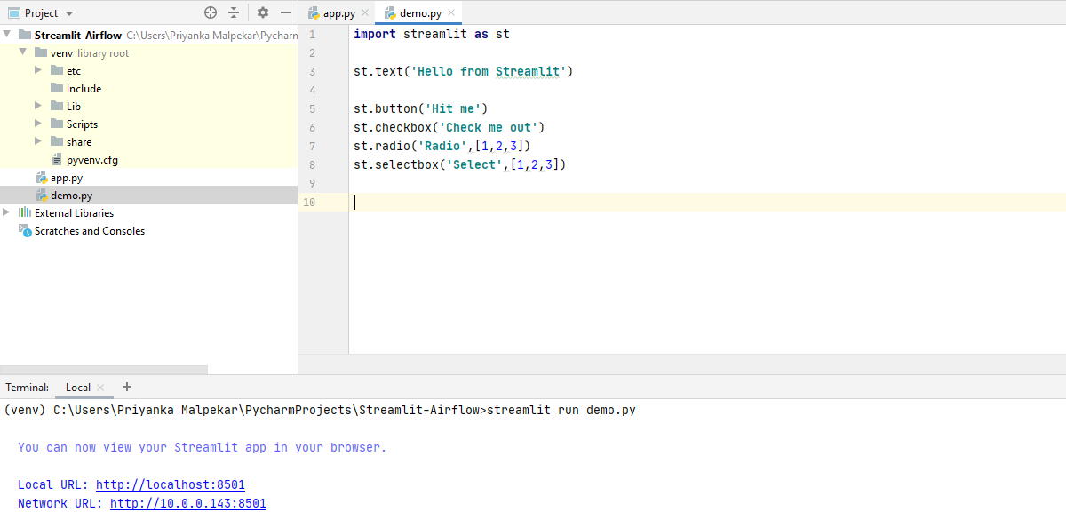

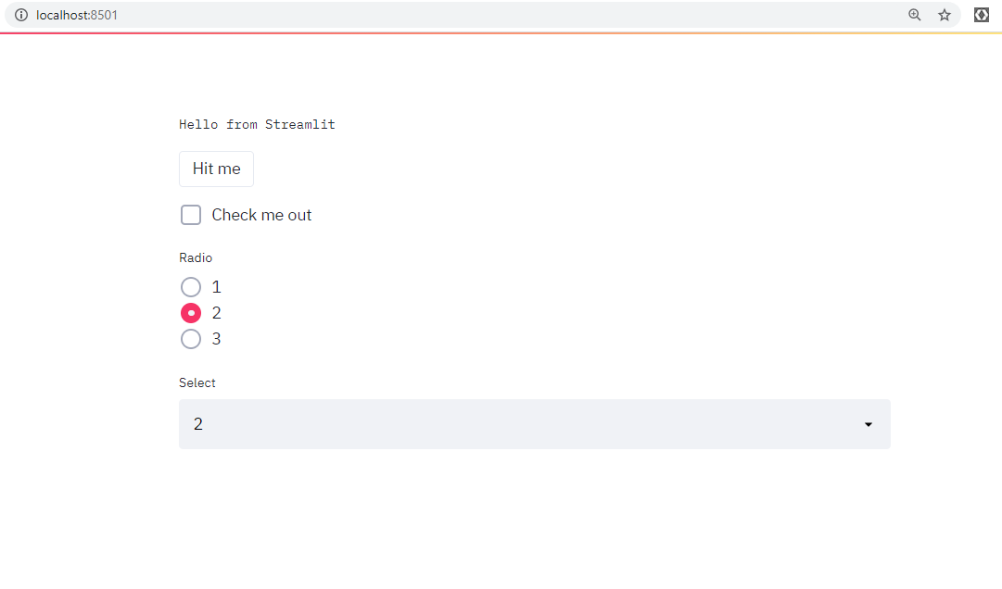

* Streamlit run app.py

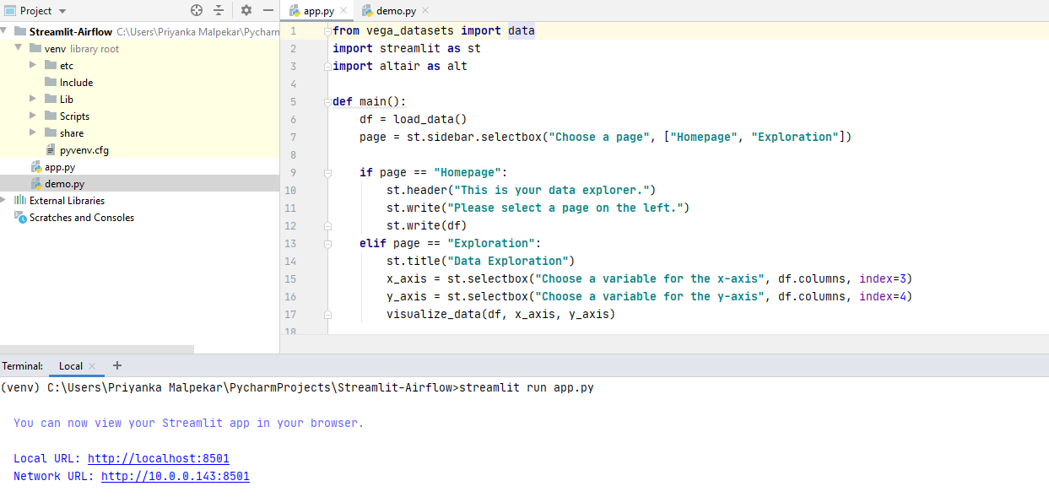

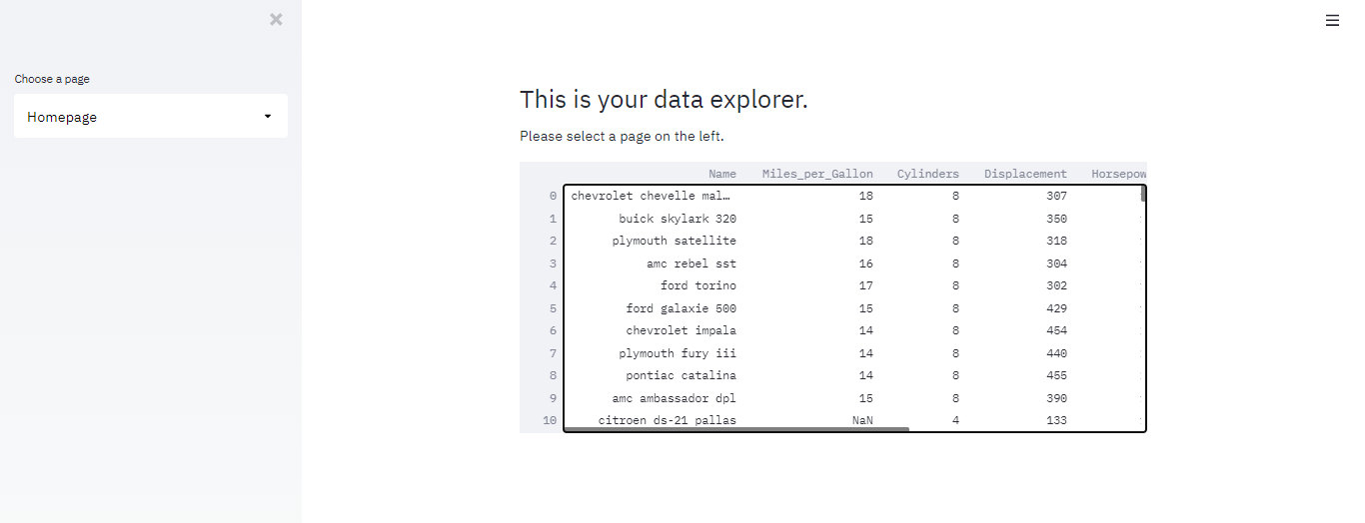

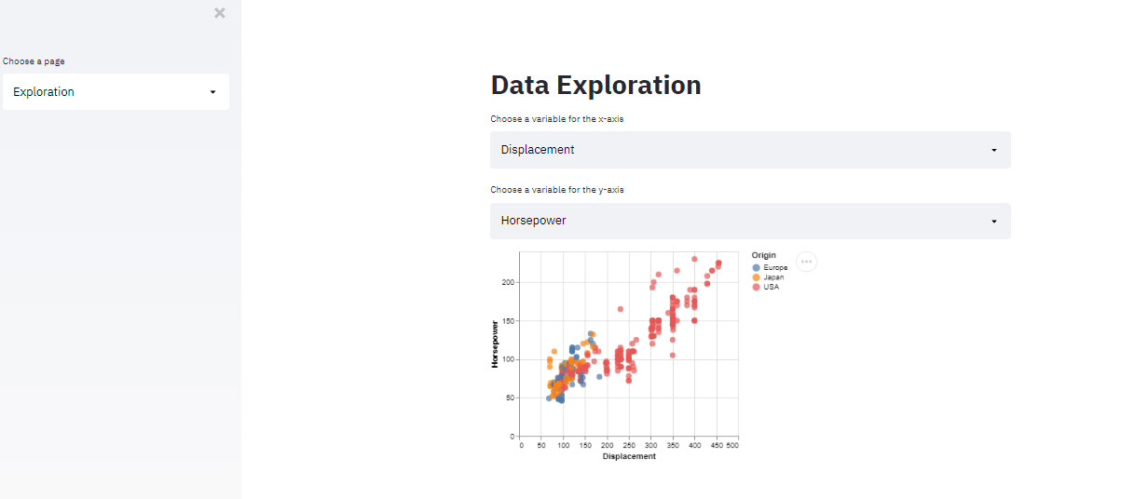

# Lessons Learned

1. To build beautiful web applications using an open-source python package
2. Used to build custom web applications using data and machine learning models
3. Can be done without having any prior knowledge of web development

# References

* <https://discuss.streamlit.io/t/streamlit-cheat-sheet/4912>
* <https://github.com/streamlit/demo-uber-nyc-pickups>
* <https://github.com/streamlit/demo-self-driving>
* <https://docs.streamlit.io/en/stable/tutorial/create_a_data_explorer_app.html>
* <https://www.streamlit.io/gallery>